**HBase Assignment 2**

1.Access all the tables created in Assignment 1 and run those queries through the python API

Step 1: Connecting to the existing table used in Assignment 1

>>> import happybase

>>> connection = happybase.Connection('10.1.1.204',9090)

>>> table = connection.table('hbase_asgnmt_db:comments')

>>> print(table.row('1'))

Retrieving all the data in existing table:

*>>> import happybase*

*>>> connection = happybase.Connection('10.1.1.204',9090)*

*>>> table = connection.table('hbase_asgnmt_db:comments')*

*>>> for key, data in table.scan():*

*... print(key,data)*

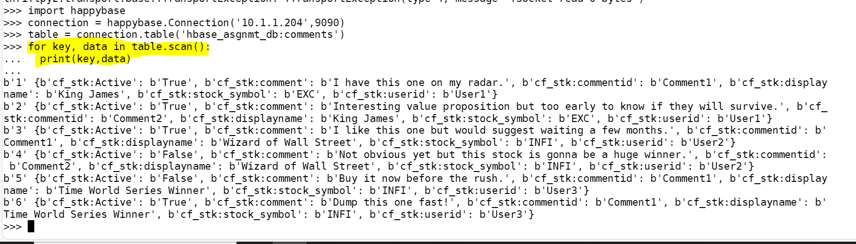

What are the comments by user3?

Running the queries used in hbase assignment 1:

import happybase

connection = happybase.Connection('10.1.1.204',9090)

table = connection.table('hbase_asgnmt_db:comments')

for key, data in table.scan(filter="SingleColumnValueFilter('cf_stk','userid',=,'substring:user3')"):

print(key,data)

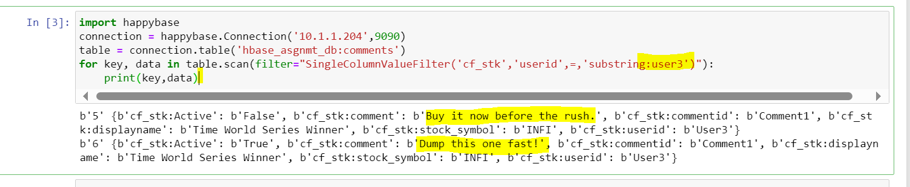

Which users have inactive comments?

import happybase

connection = happybase.Connection('10.1.1.204',9090)

table = connection.table('hbase_asgnmt_db:comments')

for key, data in table.scan(filter="SingleColumnValueFilter('cf_stk','Active',=,'substring:False')"):

print(key, data)

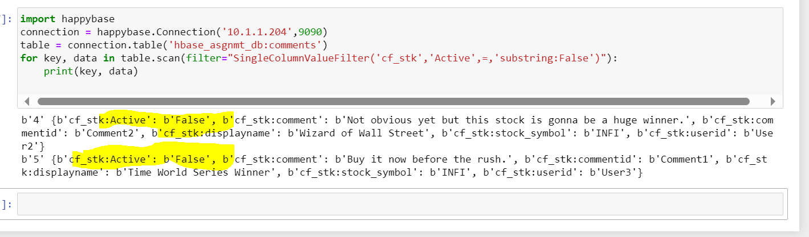

Accessing the Album table from hbase assignment 1:

>>> import happybase

>>> connection = happybase.Connection('10.1.1.204',9090)

>>> table = connection.table('hbase_asgnmt_db:k_album')

>>> for key, data in table.scan():

... print(key,data)

Run queries like

1. get all songs sung by a singer2

*import happybase*

*connection = happybase.Connection('10.1.1.204',9090)*

*table = connection.table('hbase_asgnmt_db:k_album')*

*for key, data in table.scan(filter="SingleColumnValueFilter('info','singer',=,'substring:Singer2')"):*

*print(key,data)*

2) Which singer sung for music director AK and what were the songs

2.Create new tables from python and insert some data in to those tables

*>>> import happybase*

*>>> connection = happybase.Connection('10.1.1.204',9090)*

*>>> connection.create_table(*

*...*

*... 'my_sample_table',*

*...*

*... {'cf1': dict(max_versions=10),*

*...*

*... 'cf2': dict(max_versions=1, block_cache_enabled=False),*

*...*

*... 'cf3': dict(), # use defaults*

*...*

*... }*

*...*

*... )*

*>>> table = connection.table('my_sample_table')*

*>>> table.put(b'row-key1', {b'cf1:name': b'Apple', b'cf1:colour': b'Red'})*

*>>> table.put(b'row-key2', {b'cf1:name': b'Orange', b'cf1:colour': b'Orange'})*

*>>> table.put(b'row-key3', {b'cf1:name': b'Grapes', b'cf1:colour': b'Purple'})*

*>>> table.put(b'row-key3', {b'cf1:name': b'Mango', b'cf1:colour': b'Yellow'})*

*>>> for key, data in table.scan():*

*... print(key, data)*

*...*

*b'row-key1' {b'cf1:colour': b'Red', b'cf1:name': b'Apple'}*

*b'row-key2' {b'cf1:colour': b'Orange', b'cf1:name': b'Orange'}*

*b'row-key3' {b'cf1:colour': b'Yellow', b'cf1:name': b'Mango'}*

*>>>*

